

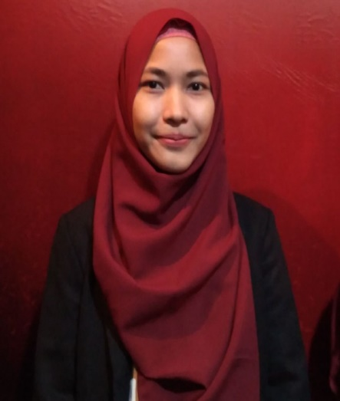

**CURRICULUM VITAE**

**Gita Pertiwi**

**SUMMARY**

I am a student of UIN Jakarta, my full name is Gita Pertiwi. This year I am 19 years old, in other words my productive age. I do not have any serious congenital disorders or illnesses and I am in good physical and mental health. I have an interest in business and design grafis.

**ADDRESS**

**Perumahan Bilabong Permai, Jl. Rajawali XI No.7 blok C1L, RT/RW :01/17 Kel. Cimanggis, Kec. Bojong Gede, Bogor-West Java**

**PROFILE**

Full Name : Gita Pertiwi

Place, Date of Birth : Tegal, 01 June 2001

Height : 154 Cm

Weight : 49 Kg

Religions : Moslem

**EMAIL**

Status : Single

Nationality : Indonesia

**pertiwigita@gmail.com**

**EDUCATION**

**PHONE NUMBER**

MI Nurul Huda (2007-2013)

SMPN 250 Jakarta (2013-2016)

**0857-1440-3667**

**085776507656**

SMAIT Darul Kholidin, Boggor (2016-2019)

UIN Syarif Hidayatullah University Jakarta (2019-up to present)

**EXPERIENCES**

**Had been the student council for the arts at SMAIT Darul Kholidin (2018-2019)**

**KEMAMPUAN**

ABLE TO RUN MS OFFICE (WORD, EXCEL and POWER

PpPPPPPPOINT) POINT

ABLE TO DESIGN GRAFIS

COOKING